Hello World! And um… Nintendo 64?

Hello everyone, in this piece of tutorial I am going to teach you Nintendo 64’s basics(or servos and gizmos if you wish). Let’s start, shall we?

This guide is targeted at people who knows C at an intermediate level.

*Chapter 1. Setting up the N64 Environment;*

We’ve all got to start from somwhere and first step here is to set our own development environment.

For this phase I HEAVILY recommend you to get a development kit for N64.If not please use Project 64 and a VM for Windows XP or SGI Indy in MAME.

Now let’s start from all the beginning and teach you how to set up the VM.

-You will need to install Oracle VM VirtualBox from <https://www.virtualbox.org/wiki/Downloads> .

-Also you will need a Windows XP SP 2 X64 ISO file.

-Finally, the ISO’s needed for N64 SDK;

<https://ultra64.ca/files/software/nintendo/Nintendo_64_Developers_Toolkit_v5.0/Nintendo_64_Developers_Toolkit_v5.0.iso>

<https://ultra64.ca/files/software/nintendo/Nintendo_64_OS-PC_v2.0K/Nintendo_64_OS-PC_v2.0K.iso>

I had to delete some of my files so I will skip over mounting the iso file but here’s a quick guide;

<https://medium.com/dfclub/create-a-virtual-machine-on-virtualbox-47e7ce10b21>

However, I will explain the “Guest Additions”.

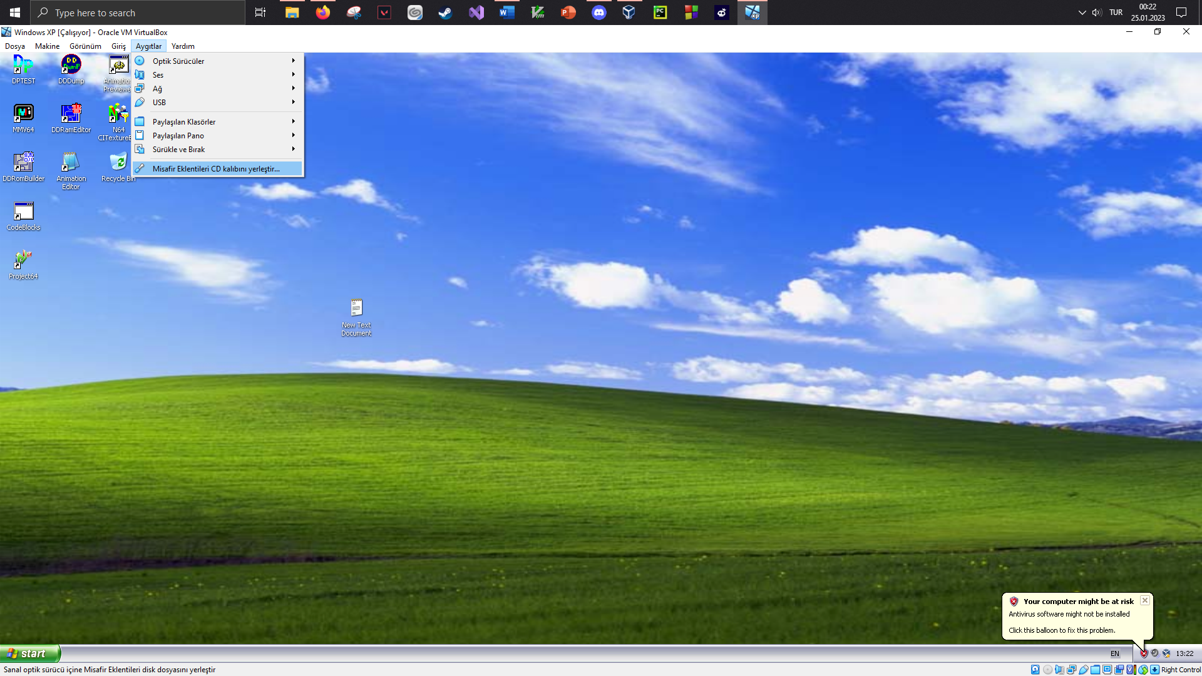

Guest Additions is basically a software/driver to connect your host machine to your VM. It is needed since you will insert the SDK ISO’s this way.

All you need to do is create a directory and add it to the shared folders in the VM settings.

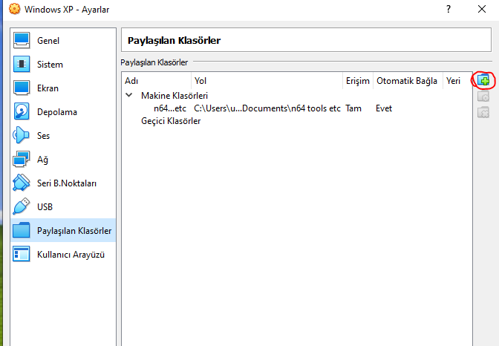

In order to add the shared folder, click on the button circled in red.

After you have mounted the SDK ISO’s, just execute and go through the installation process.

*Chapter 2. N64 OS and Other Software and Libraries*

The N64 OS (Operating System) is the software that runs on the Nintendo 64 gaming console. It is responsible for managing the console's hardware and providing an interface for game developers to create games for the platform. The N64 OS is proprietary and was developed by Nintendo.

Next, we have the NuSystem, which is our SDK.

NuSystem is a software development kit (SDK) for the Nintendo 64 (N64) gaming console. It is a collection of tools, libraries, and documentation that developers can use to create games for the N64. The NuSystem SDK includes a compiler, a linker, and a set of libraries for handling various aspects of the N64's hardware, such as the graphics processing unit (GPU) and the audio processing unit (APU). It also includes a debugging tool and a performance analysis tool to help developers optimize their games for the N64's hardware. Let’s move on to the libraries.

The main libraries that are included in the NuSystem SDK for the Nintendo 64 include:

1. Graphics Library: This library provides an interface for the N64's graphics processing unit (GPU) and includes functions for rendering 3D graphics, textures, and polygons.
2. Audio Library: This library provides an interface for the N64's audio processing unit (APU) and includes functions for playing sound effects and music.
3. Input Library: This library provides an interface for the N64's controllers and includes functions for handling input from the joystick, buttons, and other controller features.
4. Memory Management Library: This library provides an interface for the N64's memory and includes functions for managing and allocating memory for the game.
5. Math Library: This library provides an interface for the N64's math coprocessor and includes functions for performing mathematical calculations, such as trigonometry and linear algebra.
6. System Library: This library provides an interface for the N64's system functions and includes functions for managing the system's state and handling system-level events.
7. RSP Library: This library provides an interface for the N64's RSP coprocessor and includes functions for handling the geometry and lighting of 3D graphics.

These libraries are provided in the form of C/C++ header files and the functions can be called by game developers to perform specific task, but the developer has to manage the memory and resources by themselves.

Differently, The N64 SDK on SGI machines also includes a set of libraries for creating and manipulating 3D graphics, such as the N64 Graphics Synthesizer Library (GSYL) and the N64 RSP Library. The GSYL library provides an interface for the N64's graphics processing unit (GPU) and includes functions for rendering 3D graphics, textures, and polygons. The RSP library provides an interface for the N64's RSP coprocessor and includes functions for handling the geometry and lighting of 3D graphics.

**-Software Overview-**

MMV:Monegi Multi Viewer (MMV) is a tool that is included in the N64 SDK for viewing and editing 3D models used in N64 games. It is a 3D model viewer that allows developers to view, edit, and export 3D models in various file formats, including the N64's own native format.

MMV allows developers to view and manipulate 3D models in a 3D environment, including rotating, scaling, and moving the models. It also includes a variety of editing tools, such as the ability to adjust lighting, add textures, and apply different shading effects.

MMV also allows developers to export 3D models in various file formats, such as .3ds, .obj, .dae, .fbx, and .stl, which can then be used in other 3D modeling and animation software. This is useful for developers who need to import 3D models from other software or for backup purposes.

DPTest: DPTest (Display Processor Test) is a tool that is included in the Nintendo 64 SDK for testing and debugging the display processor of the N64 console. The display processor is responsible for displaying images on the screen, and DPTest allows developers to test and verify that it is functioning correctly.

DPTest provides a set of test patterns and functions that can be used to test the display processor, including color bars, resolution patterns, and geometric shapes. Developers can use these test patterns to check for visual artifacts, such as distortion or color bleeding, and verify that the display processor is displaying images correctly.

DPTest also includes a set of debugging features, such as the ability to view the contents of the frame buffer, which is the memory used by the display processor to store the current frame being displayed on the screen. Developers can use this feature to diagnose and fix issues with the display processor, such as incorrect rendering or memory leaks.

Animation Editor: The animation editor is a tool that is included in the Nintendo 64 (N64) Software Development Kit (SDK) for creating and editing animations for use in N64 games. It allows developers to create animations using 3D models, and edit and export them in a variety of file formats.

The animation editor allows developers to create animations by creating a series of keyframes, which are specific positions and orientations of a 3D model at a certain point in time. The editor then interpolates between these keyframes to create the animation. Developers can also adjust the timing of the animation and add sound effects and other effects.

CodeWarrior: CodeWarrior is a software development environment created by Metrowerks that was used to develop games for the Nintendo 64 console. It was one of the main IDEs used to develop games for the N64 and was included in the N64 Software Development Kit SDK.

CodeWarrior provides a set of tools for developers to write, edit, and debug code for the N64. It includes a C and C++ compiler, a linker, and a debugger that allows developers to test and debug their code on the N64 console. It also includes a set of libraries for handling various aspects of the N64's hardware, such as the GPU and APU.

CodeWarrior also includes a set of tools for creating and editing 3D models, animations and sounds, as well as other assets used in the game. It also allows developers to create and test their games directly on the N64 console, without the need to constantly transfer files between a PC and the console.

CodeWarrior was widely used by game developers to create games for the N64, due to its powerful set of tools and its ability to integrate with other N64 SDK tools like Monegi Multi Viewer and DPTest. It was available for Windows and Macintosh operating systems.

(Pretty much, CodeWarrior is not necessary to use and there are alternatives such as Code::Blocks and VS Code on your host machine.)

Texture Editor: The N64 Texture Editor (also known as "TexEd") is a tool that is included in the N64 SDK for creating and editing textures for use in N64 games. Textures are 2D images that are applied to the surface of 3D models to give them a more realistic appearance.

The N64 Texture Editor allows developers to create new textures and edit existing ones, using a variety of tools such as drawing, painting, and image manipulation tools. It also allows developers to adjust the properties of a texture, such as its transparency, its color palette, and its mip-mapping levels. Mip-mapping is a technique used to improve the performance and quality of textures by creating multiple versions of a texture, each with a different resolution.

The N64 Texture Editor also allows developers to import and export textures in a variety of file formats, such as .bmp, .jpg, .png, and .tga. This allows developers to easily use textures created in other image editing software, or to export textures for use in other game engines or platforms.

There are several software tools that can be used to dump the ROM file (Read-Only Memory file) from a Nintendo 64 cartridge and transfer it to a computer and vice versa. These tools are commonly referred to as ROM dumper or ROM dumping tools.

One popular ROM dumper software for N64 is the UltraCIC II. This is a hardware tool that sits between the N64 console and the cartridge, and it allows the ROM data to be read and dumped to a computer via USB. UltraCIC II also includes a software tool that allows the dumped ROM file to be read, and exported to a variety of file formats.

Another popular ROM dumper software is the N64 Transfer Pak. This hardware tool is a memory card that connects to the N64 controller and allows the ROM data to be read and dumped to a computer via USB.

Another option is using a software called "Doctor V64", which is a ROM dumper that utilizes the parallel port of a computer to dump the ROM data from the N64 cartridge.

For BURNING the image onto your OWN MADE cartridge;

Burning a game onto a Nintendo 64 (N64) cartridge can be a complex process and it requires a specialized hardware tool called a programmer. A programmer is a device that connects to the N64 cartridge and allows you to write the game data (ROM file) onto the cartridge's memory.

There are several types of programmers that can be used to burn games onto N64 cartridges. One popular option is the Everdrive 64, which is a high-quality flash cartridge that allows you to load N64 games from an SD card.

Another option is using a parallel port programmer, such as the Doctor V64. This type of programmer connects to the parallel port of a computer and uses software to write the game data onto the cartridge.

In both cases, you will need to have the ROM file of the game you wish to burn, which can be obtained legally by buying the game or by using a ROM dumper to dump the game from an original cartridge.

It's worth noting that burning a game onto a cartridge without permission from the copyright holder is illegal, and could lead to legal action.

Please keep in mind that this process can be risky, and if not done properly, it can damage both the programmer and the cartridge. It's important to have knowledge and experience with this type of hardware and software before attempting to burn a game on a N64 cartridge.

The only Nintendo approved way to do this is to use Partner N64. I’ll explain it as well.

*Chapter 3. Partner N64 and Hardware Specifications*

Partner N64 is a development tool for the Nintendo 64 (N64) gaming console. It is a hardware device that connects to the N64 and allows developers to run their games on the console without the need for a physical cartridge.

Partner N64 is a development cartridge that plugs into the N64's cartridge slot, it allows developers to test their games on the console without the need for burning a game to a physical cartridge. It also includes a built-in flash memory, where developers can store the game and test it on the console.

The Partner N64 also includes a built-in debugging tool, which allows developers to step through their code, set breakpoints, and inspect memory and registers. This can be very helpful in identifying and resolving bugs or issues in the game.

Partner N64 was developed by I-Circuit, which was a company that specialized in creating development tools for game consoles. It was widely used by game developers to test and debug their games on the N64 console.

Setting up the Partner N64 development tool for the Nintendo 64 gaming console can vary depending on the specific version of the tool you have, but here are the general steps you can follow to set it up:

1. Connect the Partner N64 device to the N64 console by inserting it into the cartridge slot.
2. Connect the Partner N64 to your computer via the provided serial cable.
3. Install the necessary software on your computer. This may include the Partner N64 software development kit (SDK), a driver for the serial cable, and any other required software.
4. Configure the settings for the Partner N64. This may include setting the baud rate, data bits, and parity for the serial connection, as well as configuring the memory settings for the Partner N64's flash memory.
5. Test the connection between the Partner N64 and your computer by running a test program or sending a test command from the SDK.
6. Once the connection is established, you can use the Partner N64 SDK to write and debug your game code on the N64 console.

Setting up the Partner N64 development tool on a Silicon Graphics Inc. (SGI) machine can vary depending on the specific version of the tool you have and the operating system of the SGI machine you are using, but here are the general steps you can follow to set it up:

1. Connect the Partner N64 device to the N64 console by inserting it into the cartridge slot.
2. Connect the Partner N64 to your SGI machine via the provided serial cable.
3. Install the necessary software on your SGI machine. This may include the Partner N64 software development kit (SDK), a driver for the serial cable, and any other required software. Make sure that the software is compatible with the operating system of your SGI machine.
4. Configure the settings for the Partner N64. This may include setting the baud rate, data bits, and parity for the serial connection, as well as configuring the memory settings for the Partner N64's flash memory.
5. Test the connection between the Partner N64 and your SGI machine by running a test program or sending a test command from the SDK.
6. Once the connection is established, you can use the Partner N64 SDK to write and debug your game code on the N64 console.

Please follow the steps carefully to not make any faulty setups of PN64.

And this ends Chapter I…

For now.

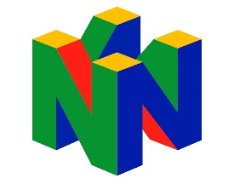

This guide was made by Crystalsoup.

Hope I can help.

Contact me via @crystalsoupi on Instagram and

Crystalsoup#3522 on Discord.

All rights goes to Nintendo and Silicon Graphics Inc.This guide is %100 profit free and just a hobby Project. Thanks for your support.

-Crystal”Mina”